Sixth Form

AAQ Human Biology (OCR)

Bridging Work Booklet


Name:…………………………………………………………………………………………………….

Welcome to HGS Human Biology!
This bridging work is designed to help you bridge the gap between your GCSE Science studies and the expectations of Human Biology.
Why do bridging work?
Preparation is crucial for studying an AAQ in Human Biology. After completing these exercises, you will need to highlight any areas that you really had trouble understanding. We are expecting you to put 100% effort into these tasks to show your commitment to the 1year course. All of these are essential in the understanding of the foundations of biology.
We want you to be successful in Human Biology and what this takes at GCSE is different to what is required at A-level. Although you have fewer subjects, there are different skills post-16 and the volume of work is greater due to the increased demand of depth and detail.
Bridging work should help you to gauge your current understanding of the subject and introduce you to the depth of understanding that is required for study at post-16.
Is the bridging work assessed?
Yes. In September, your subject teacher will ask you for your bridging work and it will be assessed. Teachers can diagnose your strengths and weaknesses and begin to support you in a more targeted way.
Human Biology Certificate H049
Studying Human Biology (or, in fact any subject) at post-16 will require you to be highly organised and effective with your own independent work. Not only will you have to balance workload of this subject and the other subjects you have chosen, but you will also be required to commit to the subject and do the best you can.
Anyone not completing the work or producing that or a poor quality will be spoken to and asked to re-consider whether this is the right course for you. Please use resources such as the internet, library and your Biology GCSE notes to help you complete this booklet.
As part of your AS/A level studies you will have 10 lessons a fortnight in your timetable. In these lessons you will cover all the theory and practical work required for the course. You are also expected to spend at least five hours a week on your Human Biology work outside of lessons. This will include homework tasks, pre-reading, independent study tasks, making additional notes, reviewing lesson materials and reading around the subject. To allow you to make a start on this, a suggested reading list has been included at the end of this pack.

Examination Details
OCR Level 3 Alternative Academic Qualification Cambridge Advanced National in Human Biology (Certificate)
For this qualification, students must complete three units:
• One mandatory externally assessed unit
• Two mandatory NEA units
Number and duration of external assessments;
- One externally assessed unit
- Exam is 1 hr 15minutes
Unit Number | Unit title | Guided learning hours (GLH) | Assessment method | Certificate
F170 | Fundamentals of human biology | 80 | EA | M
F172 | Genetics | 50 | NEA | M
F173 | Biomedical techniques | 50 | NEA | M

You should bring this bridging work with you to your first year 12 Biology lesson in September.
Fundamentals of human biology | Genetics | Biomedical techniques
F170 | F172 | F173
Topic Area 1 Human cells and tissues | Topic Area 1 Fundamentals of genetics | Topic Area 1 What biomedical science
Topic Area 2 Human physiology, organs and systems | Topic Area 2 Mode of inheritance | Topic Area 2 Diagnostic techniques: cells and microscopy
Topic Area 3 Key concepts in endocrinology, neurobiology and reproduction | Topic Area 3 Genetic counselling and genetic testing | Topic Area 3 Diagnostic techniques: biological molecules
Topic Area 4 Basics of microbiology | Topic Area 4 Gene therapy and genetic engineering | Topic area 4 Planning a clinical investigation
 |  | Topic area 5 Report writing

Securing: Complete section A
Processing: Complete section B
Exploring: Complete section C

If you need to do more preparation……
To support your learning, you will what to perhaps purchase some of the following textbooks to support your understanding of key skills as currently there isn’t a specific textbook for Human Biology, there is an overlap with between Biolgy;
Try “Head start” to A level Biology
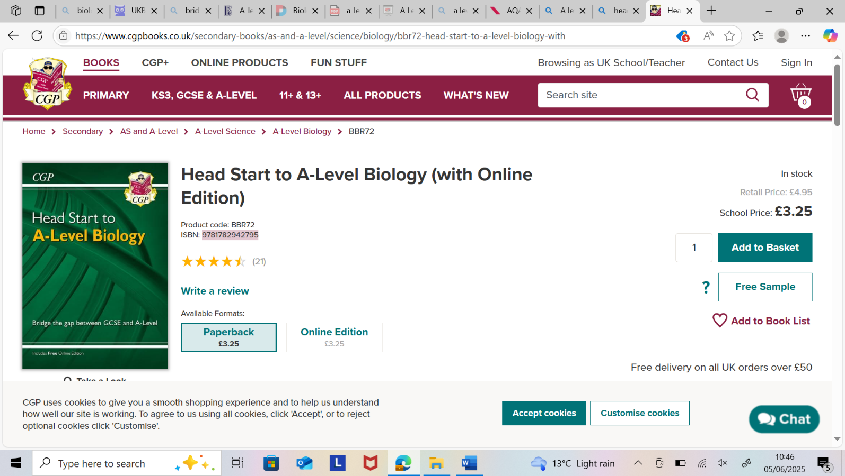
ISBN 9781782942795
Buy online at: https://www.cgpbooks.co.uk/
Online £4.95
It helps recap all the tricky topics from GCSE that AS builds on.
It is ideal preparation for September no matter what GCSE option you
have followed. It will also be useful for reference throughout the course.

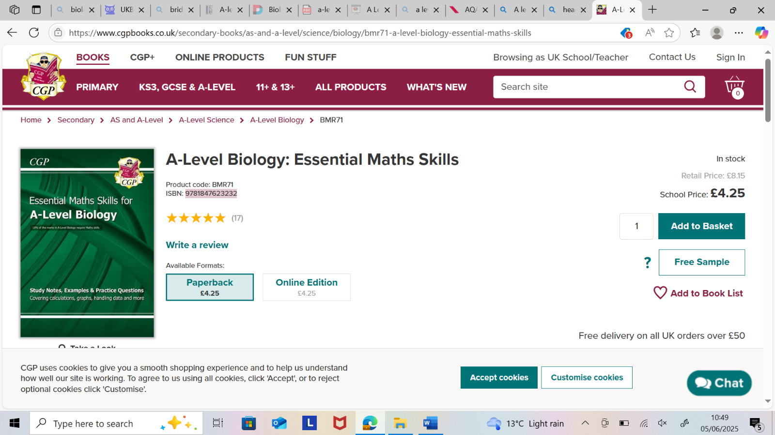
Try “A level Biology: Essential maths skills”
ISBN 9781847623232
Buy online at https://www.cgpbooks.co.uk/
Online £8.15
It helps to take your through step by step calculations from
calculating means, standard deviations to statistical testing.
It is ideal support throughout the course.
Cambridge Advanced National Alternative Academic Qualification (AAQ) Human Biology Revision Bootcamp
https://www.primrosekittenacademy.com/course/ocr-level-3-alternative-academic-qualification-human-biology-revision-bootcamp?hsCtaAttrib=187170233960
Primrose Kitten Academy has designed materials to support your understanding throughout the length of this course.
Further to these resources, your teachers are, of course, an excellent source of support both in and out of lessons.
Additional texts will be available in the school library and a full copy of the specification (you should download this for use in lessons), past papers etc. can be accessed through the AQA website:
https://www.ocr.org.uk/Images/697578-specification-cambridge-advanced-national-in-human-biology.pdf?hsCtaAttrib=137065049433

Useful Websites
AQA A-level Biology Revision - PMT
https://www.physicsandmathstutor.com/biology-revision/a-level-aqa/
Cognito Science (revision tools)
https://cognitoedu.org/home
Seneca (revision tools-will be given a login in September)
https://senecalearning.com/en-GB/
Youtube
Primrose Kitten
https://www.youtube.com/channel/UCBgvmal8AR4QIK2e0EfJwaA
Amoeba Sisters
https://www.youtube.com/@amoebasisters

Section A activities

Useful information
There are a number of activities throughout this resource. The answers to which your teacher will provide in September.

SI Units
Every measurement must have a size and a unit. Sometimes, there are different units available for the same type of measurement. For example, ounces, pounds, kilograms and tonnes are all used as units for mass.
To reduce confusion, and to help with conversion between units, there is a standard system of units called SI units which are used for most scientific purposes.
These units have all been defined by experiment so that the size of say a metre in the UK is the same as a metre in China.
The seven SI base units are;
Physical quantity | Usual quantity symbol | Unit | Abbreviation
Mass | m | kilogram | kg
Length | l or x | metre | m
Time | t | second | s
Electric current | I | ampere | A
temperature | T | kelvin | K
Amount of substance | N | mole | mol
Luminous intensity | (not used at A level) | candela | cd

All other units can be derived from the SI base units. For example, area is measured in square metres (m²) and speed is measured in metres per second (ms⁻¹).
It isn’t always appropriate to use a full unit. For example, measuring the width of a hair or the distance between Manchester and London in metres would the numbers to be difficult to work with.
Prefixes are used to multiply each of the units. The most common ones are centi (meaning 1/100), kilo (1000) and milli (1/1000).
There are a wide range of prefixes. The majority of quantities in scientific contexts can be quoted using prefixes that are multiples of 1000. For example, a distance of 33000m would be quoted as 33km.

The most common prefixes are:
Prefix | Symbol | Multiplication factor
Tera | T | 10¹² | 1 000 000 000 000
Giga | G | 10⁹ | 1 000 000 000
Mega | M | 10⁶ | 1 000 000
kilo | k | 10³ | 1000
deci | d | 10⁻¹ | 0.1 | 1/10
centi | c | 10⁻² | 0.01 | 1/100
milli | m | 10⁻³ | 0.001 | 1/1000
micro | µ | 10⁻⁶ | 0.000 001 | 1/1 000 000
nano | n | 10⁻⁹ | 0.000 000 001 | 1/1 000 000 000
pico | p | 10⁻¹² | 0.000 000 000 001 | 1/1 000 000 000 000
femto | f | 10⁻¹⁵ | 0.000 000 000 000 001 | 1/1 000 000 000 000 000

Activity 1
Converting Units
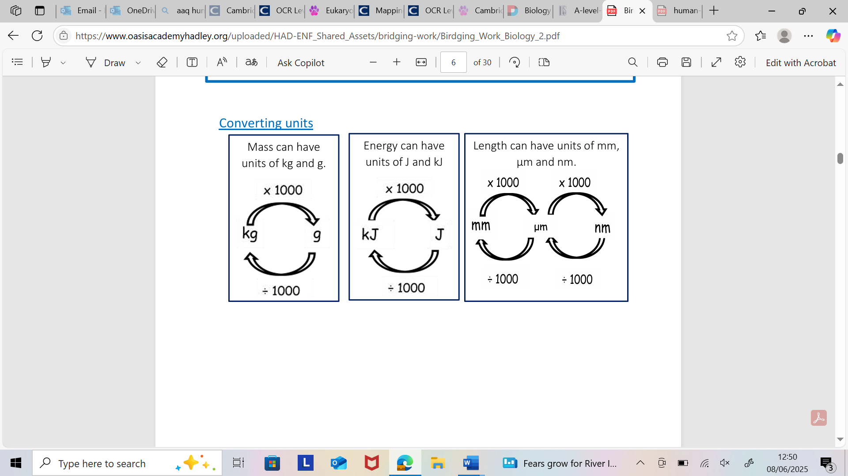
Convert into Metres | Convert into µm | Areas. How many? | Volume. How many?
1.70nm | 1.4m | 1.µm²in a m² | 1.mm³ in a cm³
2.5µm | 2.200nm | 2.µm² in a mm² | 2.µm³ in a mm³
3.1mm | 3.17mm
4.0.2mm | 4.0.3nm
Answers | Answers | Answers | Answers
1. | 1. | 1. | 1.
2. | 2. | 2. | 2.
3. | 3.
4. | 4.

1. What is the length in mm of a bacterium 50µm long?
2. The total surface area of alveoli in a human lung was estimated at 35m²
What is this in cm²?
Show your working.

3. The human body contains 4700 cm³ of blood.
What is this volume in m³?
Show your working.

4. In an enzyme investigation, 10 g of product was produced in 30 minutes.
What unit would be most appropriate for the rate of this reaction?
Calculate the rate of the reaction.

5. What is the mass in grams of a 15kg soil sample?

6. The volume of solution in an investigation was given as 650mm³
What is the volume of this solution in cm³?

7. A student was carrying out an investigation into the rate of change in volume of air in the lungs during a period of exercise. What would be the most appropriate unit to use in this investigation?

Standard Form
Standard form is a system of writing numbers, which can be particularly useful for working with very large or very small numbers. It is based on using powers of 10 to express how big or small a number is.
Activity 2 Convert from and to Standard Form
Question | Answers
- a) 5.239 x 10³
- b) 4.543 x 10⁴
- c) 9.382 x 10²
- d) 6.665 x 10⁶
- e) 1.951 x 10²
- f) 1.905 x 10⁵
- 65345
- 28748
- 548454
- 486856
- 70241
- 65865758

Important vocabulary for practical work
You will have come across most of the words used in practical work in your GCSE studies. It is important that you use the right definition for each word. Please complete the subsequent activities for September.
Activity 3
Join the boxes to link the word to the definition- or colour code
Accurate |  | A statement suggesting what may happen in the future.
Data |  | An experiment that gives the same results when a different person carries it out, or a different set of equipment or technique is used.
Precise |  | A measurement that is close to the true value.
Prediction |  | An experiment that gives the same results when the same experimenter uses the same method and equipment.
Range |  | Physical, chemical or biological qualities or characteristics.
Repeatable |  | A variable that is kept constant during an experiment.
Reproducible |  | A variable that is measured as the outcome of an experiment.
Resolution |  | This is the smallest change in the quantity being measured (input) of a measuring instrument that gives a perceptible change in the reading.
Uncertainty |  | The interval within the true value can be expected to lie.
Variable |  | The spread of data, showing the maximum and minimum values of the data.
Control Variable |  | Measurements where repeated measurements show very little spread.
Dependent Variable |  | Information, in any form, that has been collected.

Cells
All life on Earth exists as cells. These have basic features in common.
Activity 4
Complete the table
Structure | Function
Cell-surface membrane
Chloroplast
Cell Vacuole
Mitochondria
Nucleus
Cell Wall
Chromosomes
Ribosomes

Principles of moving across boundaries
In biology, many processes involve moving substances across boundaries.
Activity 5
Match the examples to the principle(s) involved. For each, give a brief description of why it is relevant.
Osmosis |  | Examples  Potato pieces get heavier when put in pure water  The effect of salt on slugs
Diffusion |  | Drinking a sports drink  Cacti do not have thin, large leaves  Gas exchange in the lungs
Active transport |  | Absorbing nutrients from food into the body  Moving ions into cells
Changing surface area or length |  | Penguins huddling together to keep warm  Potato pieces get lighter when put in pure water

Analysing Data
Biological investigations often result in large amounts of data being collected. It is important to be able to analyse this data carefully in order to pick out trends.
Activity 6
A student investigated an area of moorland where succession was occurring. She used quadrats to measure the area covered by different plant species, bare ground and surface water every 10 metres along a transect. She also recorded the depth of the soil at each quadrat. Her results are shown in the table.
 | Area covered in each quadrat A to E in cm²
 | A | B | C | D | E
Bog Moss | 55 | 40 | 10 | - | -
Bell Heather | - | - | - | 15 | 10
Sundew | 10 | 5 | - | - | -
Ling | - | - | - | 15 | 20
Bilberry | - | - | - | 15 | 25
Heath grass | - | - | 30 | 10 | 5
Soft rush | - | 30 | 20 | 5 | 5
Sheep’s fescue | - | - | 25 | 35 | 30
Bare ground | 20 | 15 | 10 | 5 | 5
Surface water | 15 | 10 | 5 | - | -
Soil depth/cm | 3.2 | 4.7 | 8.2 | 11.5 | 14.8
    - Indicates zero cover
Calculate:
- The mode area of soft rush in the sample
- The mean soil depth
- The median amount of bare ground in the sample

Graphs
1. Use the data from the previous table to plot a scatter graph of soil depth against the area covered by bare ground, soft rush and bog moss (use different colours or markers for each).
2. What conclusions does your graph suggest?
3. How confident are you in these conclusions?
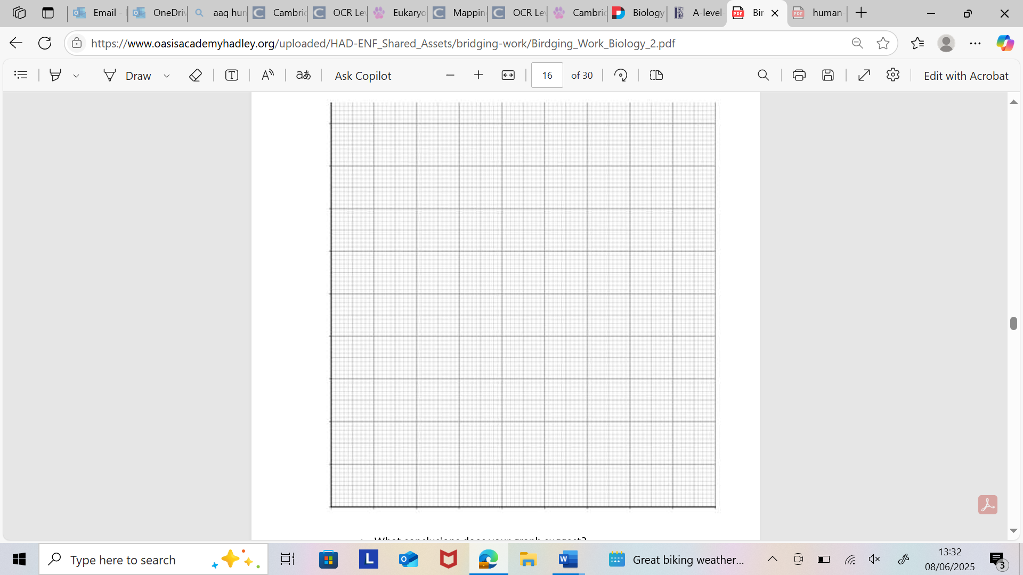

Activity 7

Lung cancer, chronic bronchitis and coronary heart disease (CHD) are associated with smoking. Tables 1 and 2 give the total numbers of deaths from these diseases in the UK in 1974.

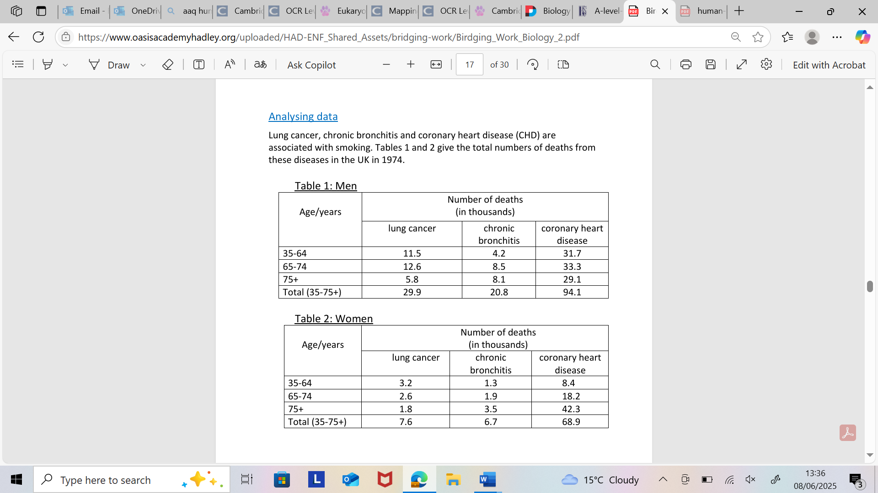
Questions | Answers
1. Of the men who died aged 35-64 from one of these three causes, what percentage of them died of lung cancer?
2. What percentage of deaths from chronic bronchitis in women happened to women aged 65-74?
3. Deaths from lung cancer drop as people get older. Is there a bigger percentage difference for men or women from 35-64 to 75+?
4. What fraction of coronary heart disease deaths of men over 34 are in the 75+ bracket? What about for women?

Section B Activities

Part 1
1. Watch the video about Vital Signs Then for the following Vital Signs:
➢ Blood Pressure
➢ Heart Rate
➢ Breathing Rate (respirations)
➢ Temperature
➢ Blood Oxygen Saturation
For each vital sign make sure your notes include:
1. Equipment used to carry out the test.
2. Basic method on how the test is carried out.
3. Image of patient having the test carried out.
4. Unit of measurement e.g. heart rate – beats per minute.
5. State normal reference range.
Part 2 -Evaluating an investigation.
Key features of an A grade student’s work, the level of detail and criticism that they can apply when evaluating their own practical procedures or those of others.
Consider the following scenario: Some students investigated the effect of the Bt toxin on insect pests that feed on maize plants. They divided the field into 3 plots and planted the following:
Plot 1 – untreated maize seedlings
Plot 2 – seedlings genetically modified to produce the Bt toxin that kills insect pests.
Plot 3 – seedlings sprayed with Bt toxin every week.
Each week a different student counted the number of seedlings that had died in each plot.
The teacher was concerned about the investigation and suggested that
a) the method may not be very valid
b) not all of the variables have been controlled
c) the results may not be accurate.
To do:
Explain why the teacher’s concerns are justified and suggest improvements to the investigation. a). Why is the method not valid? What are your suggestions for improvement?
b). Which variables have not been controlled? How could you suggest overcoming this?
c). Why may the results not be valid? What are your suggested improvements?

Use this resource if you need some prompts;
https://www.bbc.co.uk/bitesize/topics/zr8wfdm/watch/z9hsdnb

Section C Activities
Science communication is essential in the modern world and all the big scientific companies, researchers and institutions share their developments through social media platforms and through accessible presentations.
Below are suggested videos/ films/ ted talks/ websites that may be useful to prepare you for Biology A Level. Some are linked to topics at GCSE and those you will learn about at A Level, some are to give you a wider understanding.
You are not expected to watch them all- you can choose those that are most interesting to you and produce Cornell notes on them!
• https://www.ted.com/topics/biology
These ones are particularly interesting...
- https://www.ted.com/talks/paula_hammond_a_new_superweapon_in_the_fight_against_cancer?language=en
- https://www.ted.com/talks/marla_spivak_why_bees_are_disappearing?language=en
- http://ed.ted.com/lessons/the-twisting-tale-of-dna-judith-hauck
- http://ed.ted.com/lessons/where-do-genes-come-from-carl-zimmer
- http://ed.ted.com/lessons/how-to-sequence-the-human-genome-mark-j-kiel
- http://ed.ted.com/lessons/the-race-to-sequence-the-human-genome-tien-nguyen
- http://ed.ted.com/lessons/why-is-biodiversity-so-important-kim-preshoff
- http://ed.ted.com/lessons/can-wildlife-adapt-to-climate-change-erin-eastwood
- http://ed.ted.com/lessons/insights-into-cell-membranes-via-dish-detergent-ethan-perlstein
- http://ed.ted.com/lessons/what-do-the-lungs-do-emma-bryce
- https://www.ted.com/talks/robert_sapolsky_the_biology_of_our_best_and_worst_selves
Websites
1. http://www.ibiblio.org/virtualcell/index.htm - An interactive cell biology site.
2. http://www.accessexcellence.org/RC/VL/GG - A web site showing illustrations of many processes of biotechnology.
3. http://www.dnai.org/a/index.html - Explore the genetic code.
4. http://nobelprize.org - Details of the history of the best scientific discoveries.
5. http://nature.com - The site of the scientific journal.
6. http://royalsociety.org - Podcasts, news and interviews with scientists about recent scientific developments.
7. http://www.nhm.ac.uk - The London Natural History Museum’s website with lots of interesting educational material.
8. http://www.bmj.com - The website of the British Medical Journal.

Section D Activities

If you have entered the course from the combined pathway (trilogy or synergy) you may need to review the following topics;

Topics | Trilogy | Separate
Thermoregulation | X
Advanced Genetics and gene expression | X
Biotechnology | X
Reproduction hormones and IVF | Basic | In-depth
Genetic Engineering and Cloning | Limited | Detailed

Please use the following websites to support your understanding;
https://www.bbc.co.uk/bitesize/examspecs/zpgcbk7
https://www.physicsandmathstutor.com/biology-revision/gcse-aqa/

Complete the 10min test booklet and review your results and provide evidence of how you have addressed your weaknesses; mindmaps/practice questions/flashcards.

Massive Open Online Courses (MOOCs)

You might enrol on these online courses and complete the following to push you a little further (this is optional). These courses are a fantastic addition to your UCAS:
HarvardX: Cell Biology:

UniversityofCambridge: Forensic Science: DNA Analysis | edX

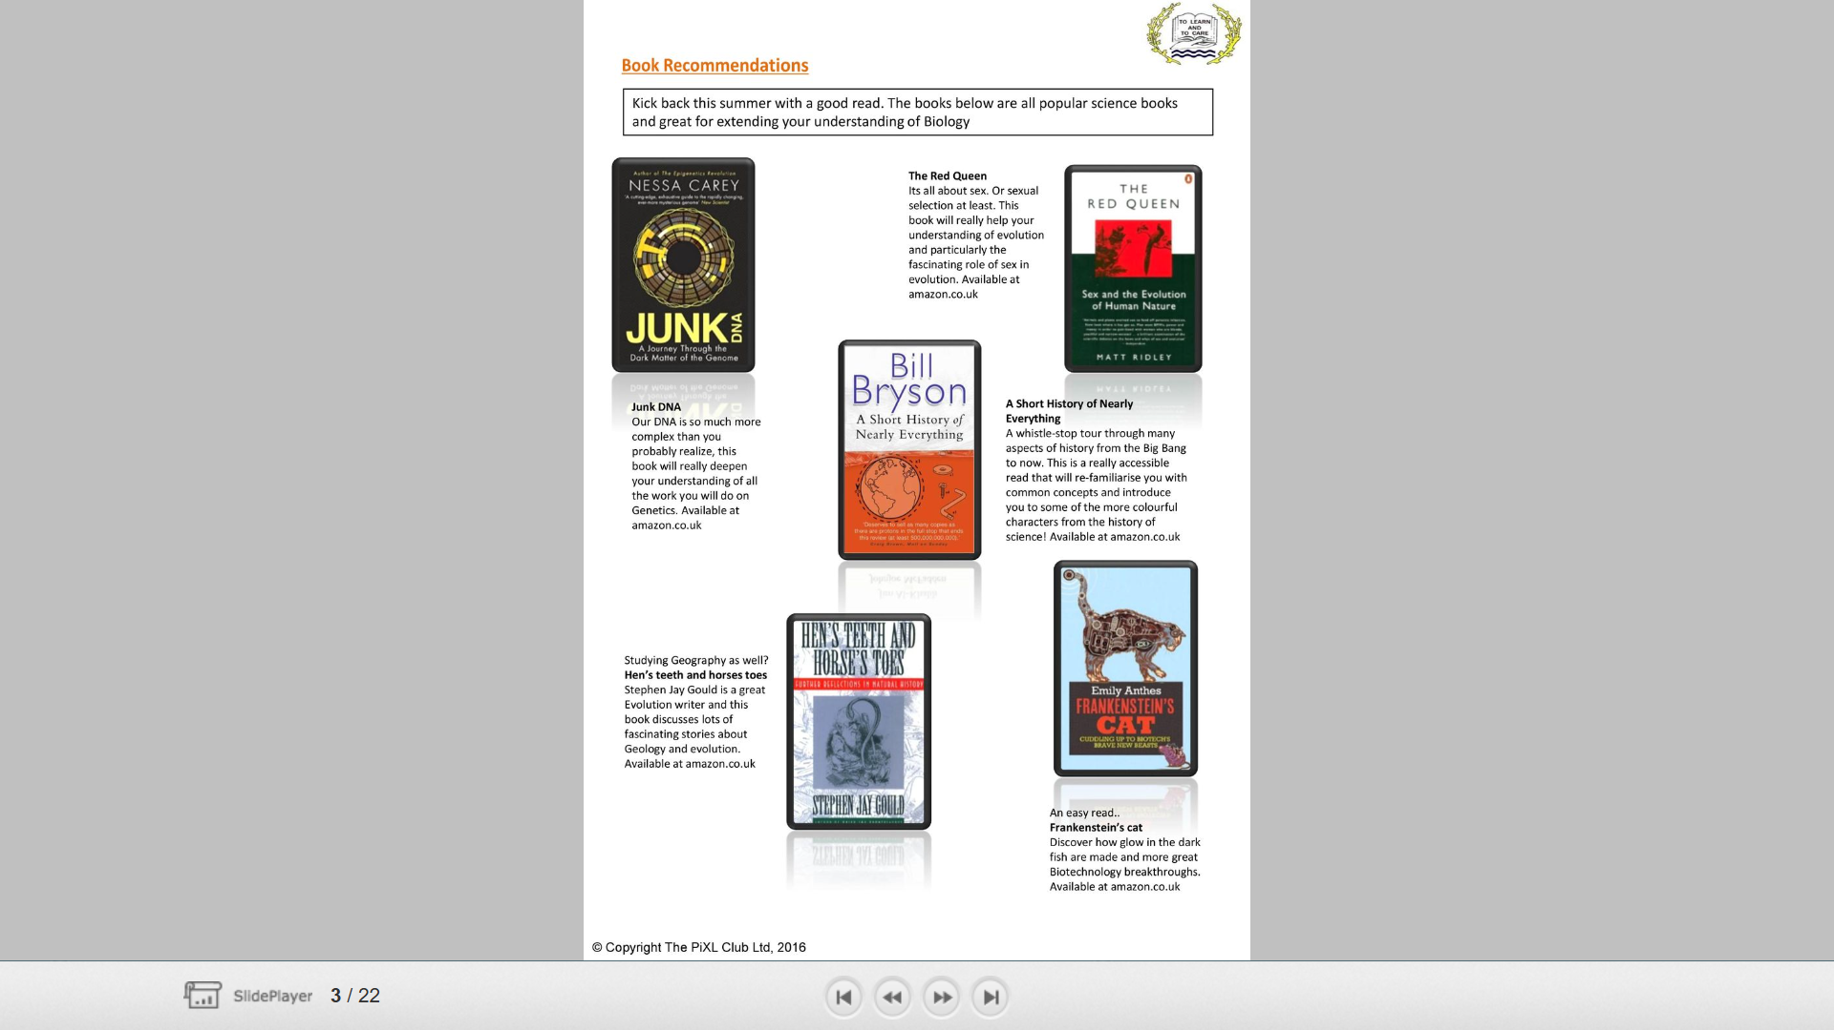
Books Richard Dawkins: The Selfish Gene;
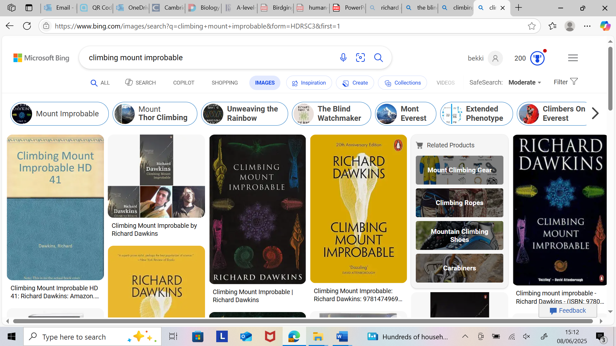

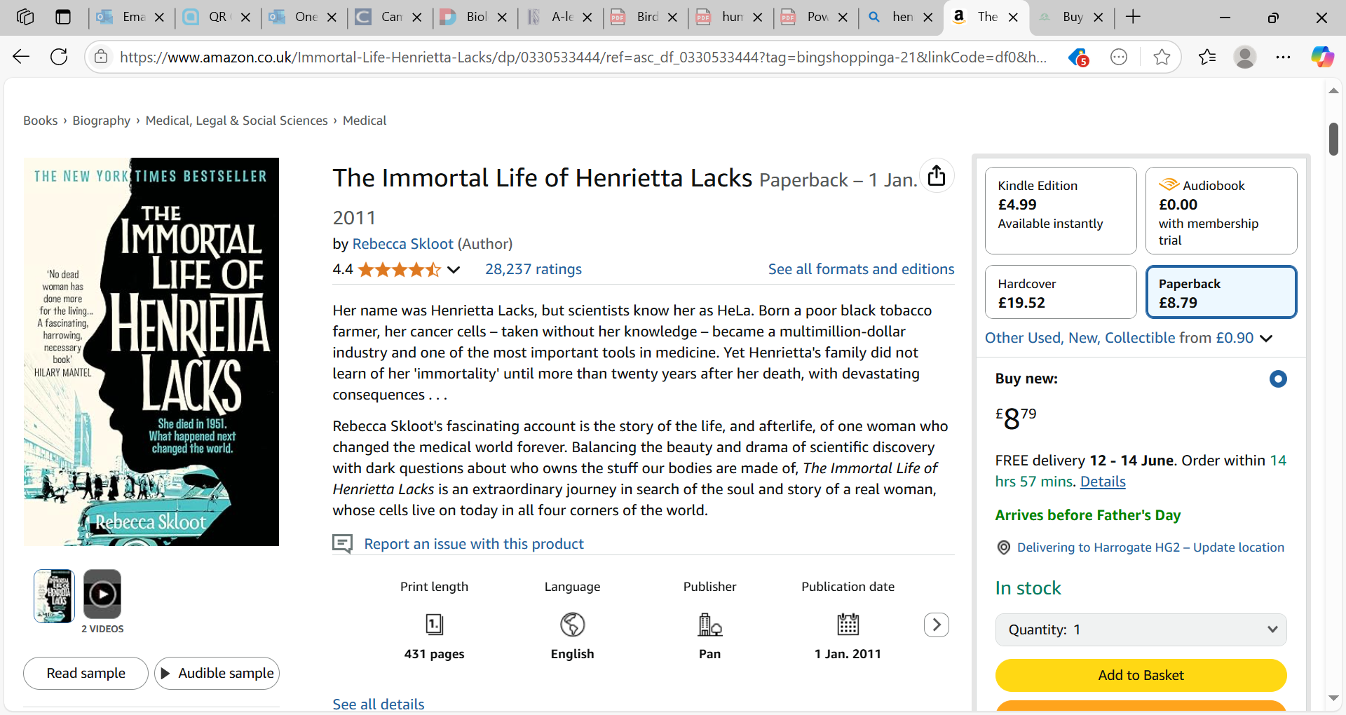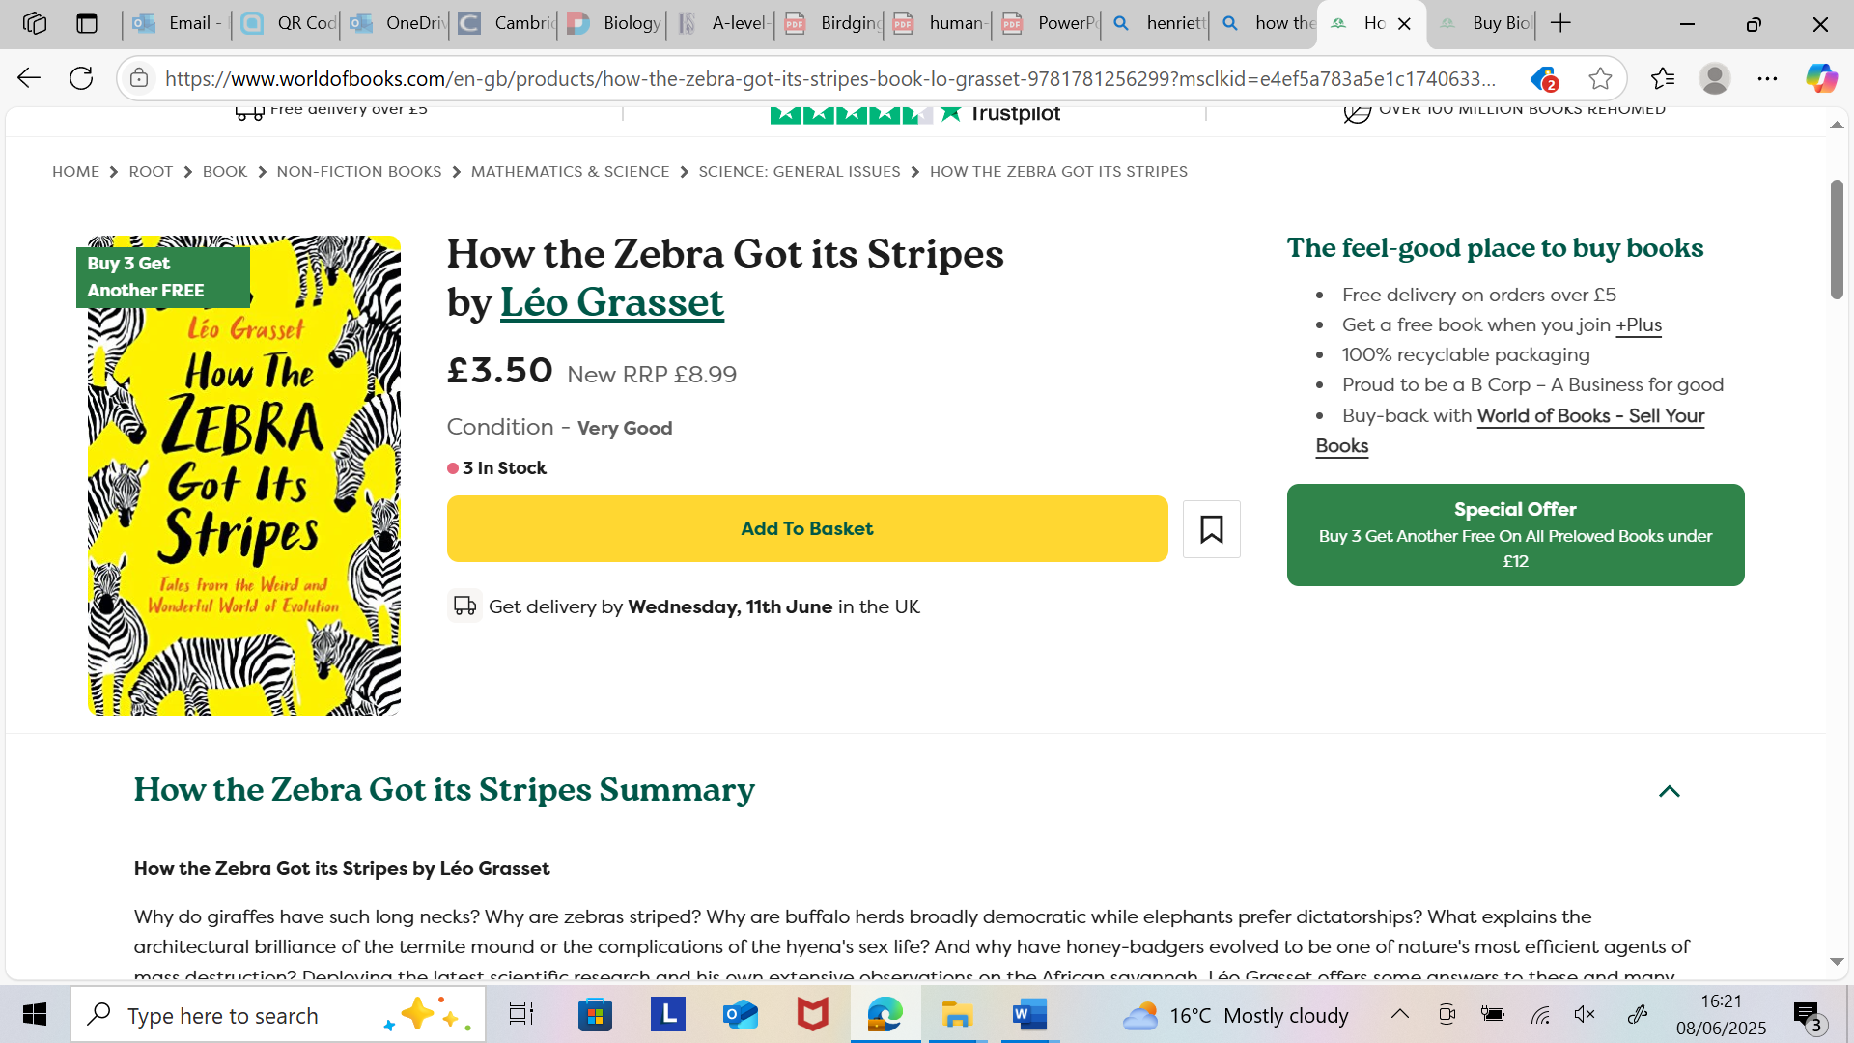
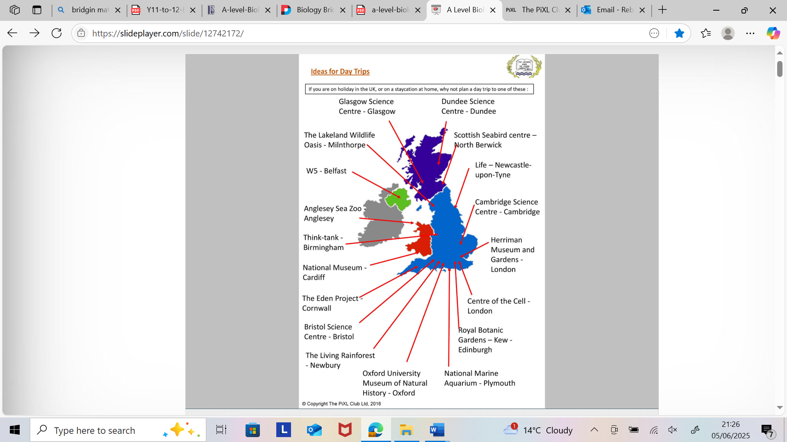

Research Activities

The Big Picture is an excellent publication from the Wellcome Trust. Along with the magazine, the company produces posters, videos and other resources aimed at students studying for GCSEs and A level. For each of the following topics, you are going to use the resources to produce one page of Cornell style notes. Use the links of scan the QR code to take you to the resources.
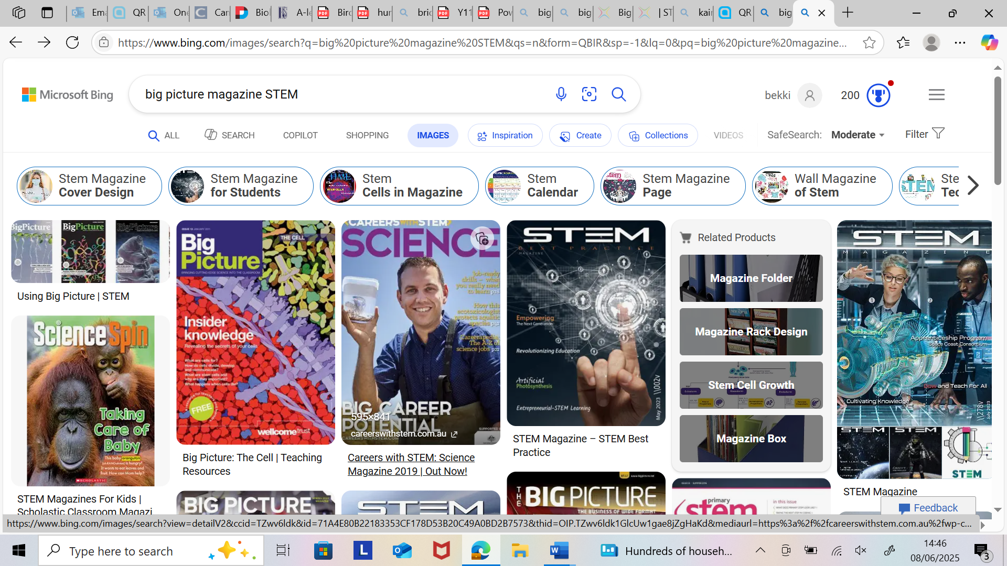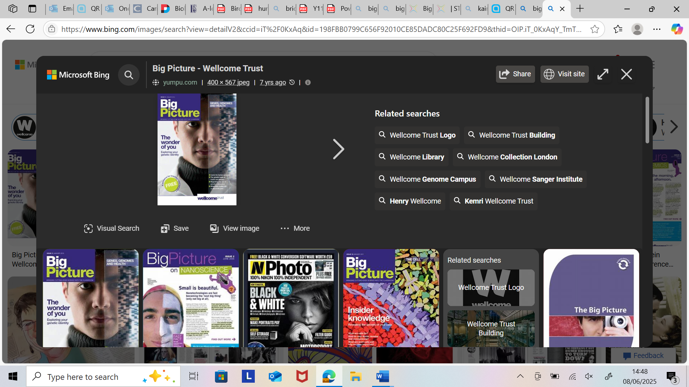
Topic 1: The Cell
https://www.stem.org.uk/resources/elibrary/resource/34589/cell-suitable-home-teaching | 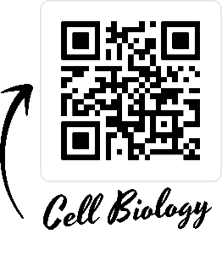
The cell is the building block of life. Each of us starts from a single cell, a zygote, and grows into a complex organism made of trillions of cells. In this issue, we explore what we know – and what we don’t yet know – about the cells that are the basis of us all and how they reproduce, grow, move, communicate and die.
Topic 2: Genes, genomes and health
https://www.stem.org.uk/resources/elibrary/resource/26570/genes-genomes-and-health-suitable-home-teaching | 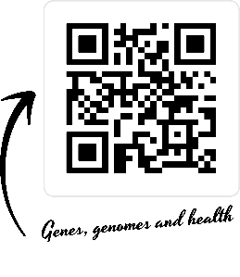
In recent years, great progress has been made in genome sequencing and understanding the huge amount of data produced. Our genes play a key part in making us who we are, but how can science help us understand our genetic identity? What can be done with this information? What should be done with this information?
Topic 3: Immune system
https://www.stem.org.uk/resources/elibrary/resource/35694/immune-system | 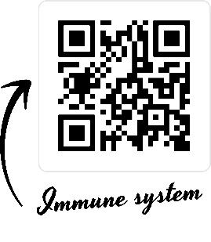
This resource looks at several aspects of the immune system including:
- The non-specific immune response
- Specific immune response and antigen recognition
- T cells and B cells
- Autoimmune disease and allergic responses
- Monoclonal antibodies
- Long term immunity and vaccination

Science on Social Media

Facebook
- Nature- the profile page for nature.com for news, features, research and events from Nature Publishing Group

- Marine Conservation Institute- publishes the latest science to identify important marine ecosystems around the world

- Science news magazine- Science covers important and emerging research in all fields of science

- BBC Science News- The latest BBC science and Environment news: breaking news, analysis and debate on science and nature around the world

X
- Carl Zimmer- Scientific writer Carl blogs about life sciences @carlzimmer
- Phil Plait- tweets about astronomy and bad science @badastronomer
- Maryn McKenna- science journalist who writes about antibiotic resistance @marynmck
- Sci Curious- feed from writer and Bethany Brookshire tweeting about good, bad and weird neuroscience @scicurious
- New Scientist- scientific journal of recent scientific developments @newscientist
- Science and Nature- Unravelling the mysteries of the natural world, one video at a time @ScienceFun16180

TikTok
- @miss.estruch.biology- A-level and GCSE Biology. Live and free lessons every Thurs 8pm
- @up.learn- Online platform to help with A level revision
- @primrose.kitten- Making revision easy on Youtube or Primrose kitten academy
- @mattgreen.jgm- the rapping science teacher
- @instituteofhumananatomy- shares facts about human biology, offering a close-up look at the human body
- @biologywitholivia offers GCSE and A level revision videos
- @billnye- Bill Nye the Science Guy offers science related content, including informative videos and engaging discussions

