**A Level Music Summer Bridging Work**

**Task 1: Key terms to learn**

You will be tested on these when we are in school in September.

|  |  |  |
| --- | --- | --- |
| Style / Genre | Concerto | Work for a soloist + orchestral accompaniment |
| Concerto Grosso | Work for a group of soloists + orchestral accompaniment  Used a lot by composers such as Corelli and Vivaldi in the Baroque period |
| Melody | Conjunct | Moves by step |
| Disjunct | Moves by leap |
| Auxiliary note (AN) | Sometimes called neighbour notes  Type of melodic decoration  2 types: upper auxiliary note + lower auxiliary note  An AN is a note that falls between two identical notes, either higher (upper AN) or lower (lower AN) |
| Note of anticipation | An unaccented non-chord note, which is an early sounding of a note from the following chord, which is then repeated within its own chord  Here we have a chord of C followed by a chord of G  The highlighted note (B) belongs to the chord of G, but comes in ‘early’  It is then repeated when we hear the chord of G, to which it belongs |
| Harmony | Inversions | Where the lowest sounding note of the chord is not the ‘root’ note    I Ib Ic |
| Substitution chords | ‘Borrowing’ a chord from the tonic major / minor, e.g. if you are in C major, you can ‘borrow’ the chord of F minor from C minor |
| Tierce de Picardie (TDP) | Minor key movement ending with a major chord I |
| Sonority | Basso continuo | Common in the Baroque period  A keyboard instrument (e.g. harpsichord / organ) plus a bass line (cello / theorbo / bass viol)  The bass line is written out, and the harpsichord player would then ‘realise’ the chords from the figured bass |
| Double stopping | String instruments (e.g. violin / cello) playing 2 strings at the same time |
| Structure | Antecedent + consequent | Question + answer phrase  1st phrase ends with an imperfect cadence (? - V)  2nd phrase ends with a perfect cadence (V – I) |
| Ritornello form | Used a lot in concertos in the Barque era  Main theme (ritornello) comes back with contrasting episodes in-between  The ritornello theme does not always have to be in the tonic key, and can be shortened |

**Task 2: Score Analysis**

EXTRACT 1

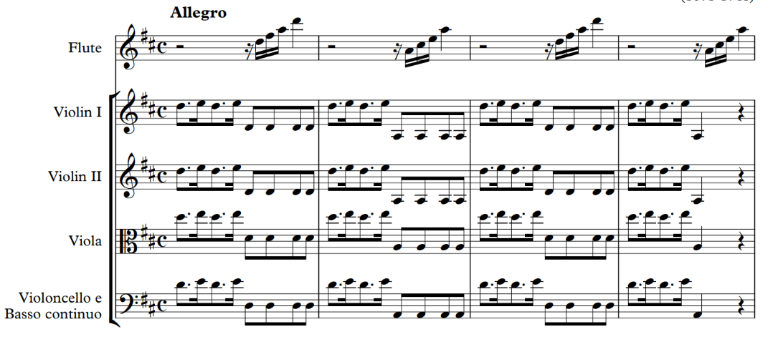

1. What key is this movement in?
2. What is the **texture** in the **strings** at the start? Hint...the violas start on a D (they are in the alto clef)
3. Describe the **melodic shape** of the solo flute in bar 1. Hint...work out the notes it is playing.
4. What are the 2 different chords that are used in the opening 4 bars?

EXTRACT 2

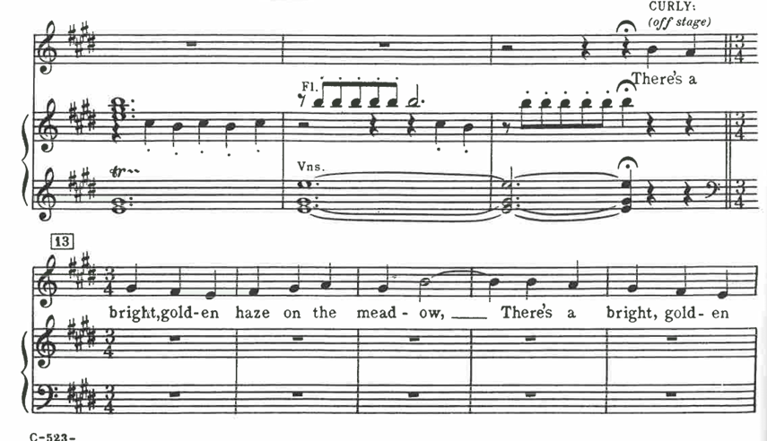

1. What is the **texture** when the singer (Curly) enters?
2. How does the **vocal melody move** most of the time?
3. What is the **interval** between ‘mead’ and ‘ow’ in bar 15?

EXTRACT 3

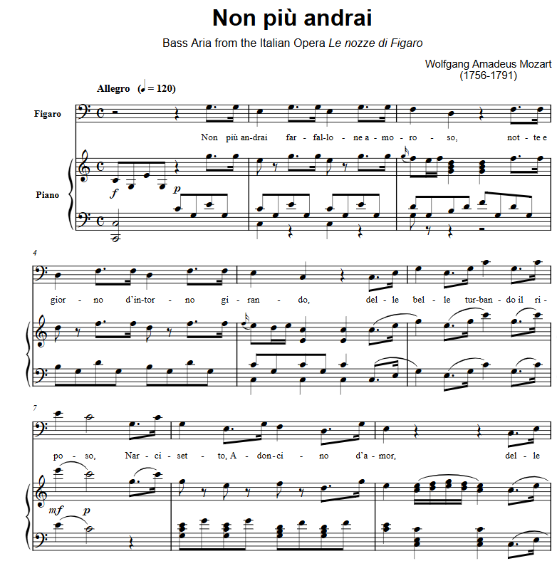

This movement is in **C major**. Complete the table below to show the chords used in the excerpt above.

|  |  |
| --- | --- |
| **Bar** | **Chord** |
| 1 |  |
| 2 |  |
| 3 |  |
| 4 |  |
| 5 |  |
| 6 |  |
| 7 |  |
| 8 (beat 1) |  |
| 8 (beat 2) |  |
| 9 |  |

**Task 3:** **Performance**

Record what you have been practising on your main instrument (or voice!)

You will be asked to show your teacher this recording when we are back in school.

**Task 4: Watch this documentary and answer the questions below.**

[Jazz Documentary Episode 1: “Gumbo” – Ken Burns | The Birthplace of Jazz](https://www.youtube.com/watch?v=plAcIpNcBKs&t=458s)

[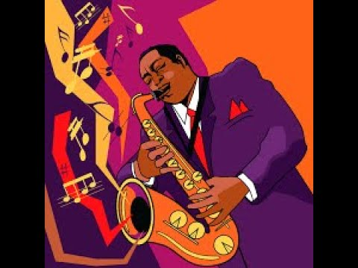](https://www.youtube.com/watch?v=plAcIpNcBKs&t=458s)

1. Where was jazz born?
2. When were slaves in America allowed to sing + dance every Sunday?
3. What did slaves from the interior of the American South bring with them?
4. What were the ‘free’ people of New Orleans called?
5. List the styles / genres of music and the different ensembles you would hear in New Orleans.
6. What was the 1st minstrel hit to be written down called?
7. What made jazz music possible?
8. How many years after the Civil War did federal troops occupy the south (reconstruction)?
9. In the 1890s – which 2 new styles of music reached New Orleans?
10. How many chords is a blues piece based on?
11. Comment on what blues songs are designed for, and what they are usually about.
12. What did musicians in New Orleans do with jazz?
13. What did they add to the ends of notes?
14. Who started to play together after segregation, and why?

**‘The Big Noise’**

1. Who started the ‘Big Noise’? Wat instrument did he play?
2. What instrument did Jelly Roll Morton play?
3. What styles of music did Jelly Roll Morton fuse?
4. What did he claim he had invented?
5. What did he call the ‘Spanish tinge’?
6. How did Sidney Bechet learn the clarinet?
7. Which band leader sold the most records?

**‘The Soul of the Negro’**

1. 1914 – what was America’s most popular music?
2. Who was the band leader who travelled with the Castles?
3. How old was he when he was an MD (Musical Director)?
4. Which song was their favourite for the foxtrot?
5. What mute did Freddie Keppard like to use?
6. Where did his band settle?
7. What opportunity did he pass up?
8. Which band made the 1st recording?
9. Which tunes did they record?

**Task 3:** **General listening**

Choose your favourite piece of music. Comment on how the elements of music are used in the table below.

**Song Title:_______________________________ Composer/Artist:_________________________**

|  |  |  |  |
| --- | --- | --- | --- |
| **Tempo** | **Tonality** | **Harmony** | **Melody** |
| **Texture** | **Instrumentation** | **Sonority / Instrumentation** | **Structure** |
| **Rhythm** | **Metre** | **Dynamics** | **General context** |