A Level Music Summer Bridging Work

Task 1: Key terms to learn
You will be tested on these when we are in school in September.
Style / Genre | Concerto | Work for a soloist + orchestral accompaniment
Style / Genre | Concerto Grosso | Work for a group of soloists + orchestral accompaniment  Used a lot by composers such as Corelli and Vivaldi in the Baroque period
Melody | Conjunct | Moves by step
Melody | Disjunct | Moves by leap
Melody | Auxiliary note (AN) | Sometimes called neighbour notes  Type of melodic decoration  2 types: upper auxiliary note + lower auxiliary note  An AN is a note that falls between two identical notes, either higher (upper AN) or lower (lower AN)  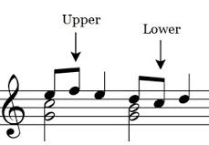
Melody | Note of anticipation | An unaccented non-chord note, which is an early sounding of a note from the following chord, which is then repeated within its own chord  Here we have a chord of C followed by a chord of G  The highlighted note (B) belongs to the chord of G, but comes in ‘early’  It is then repeated when we hear the chord of G, to which it belongs  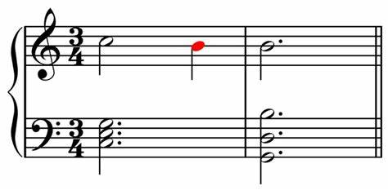
Harmony | Inversions | Where the lowest sounding note of the chord is not the ‘root’ note  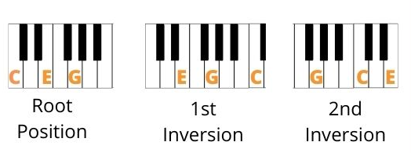  I Ib Ic
Harmony | Substitution chords | ‘Borrowing’ a chord from the tonic major / minor, e.g. if you are in C major, you can ‘borrow’ the chord of F minor from C minor
Harmony | Tierce de Picardie (TDP) | Minor key movement ending with a major chord I
Sonority | Basso continuo | Common in the Baroque period  A keyboard instrument (e.g. harpsichord / organ) plus a bass line (cello / theorbo / bass viol)  The bass line is written out, and the harpsichord player would then ‘realise’ the chords from the figured bass
Sonority | Double stopping | String instruments (e.g. violin / cello) playing 2 strings at the same time
Structure | Antecedent + consequent | Question + answer phrase  1st phrase ends with an imperfect cadence (? - V)  2nd phrase ends with a perfect cadence (V – I)
Structure | Ritornello form | Used a lot in concertos in the Barque era  Main theme (ritornello) comes back with contrasting episodes in-between  The ritornello theme does not always have to be in the tonic key, and can be shortened
Task 2: Score Analysis
EXTRACT 1
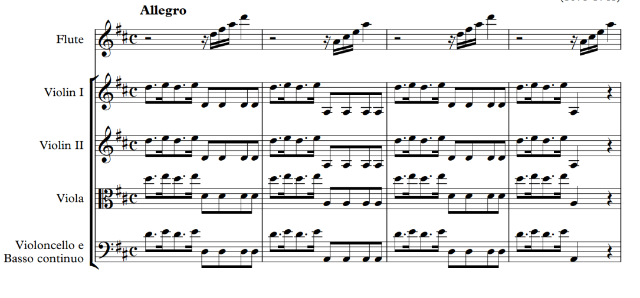
- What key is this movement in?

- What is the texture in the strings at the start? Hint...the violas start on a D (they are in the alto clef)

- Describe the melodic shape of the solo flute in bar 1. Hint...work out the notes it is playing.

- What are the 2 different chords that are used in the opening 4 bars?

EXTRACT 2
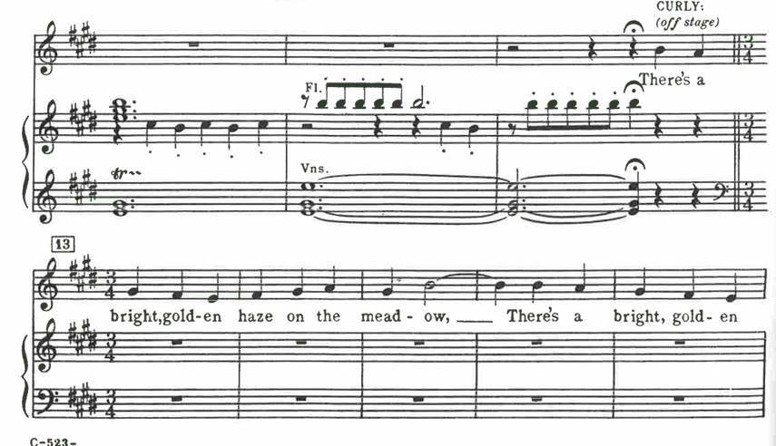
- What is the texture when the singer (Curly) enters?

- How does the vocal melody move most of the time?

- What is the interval between ‘mead’ and ‘ow’ in bar 15?

EXTRACT 3
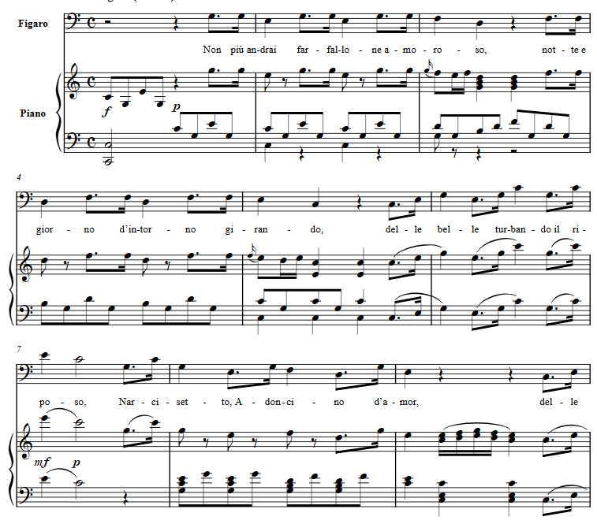
This movement is in C major. Complete the table below to show the chords used in the excerpt above.
Bar | Chord
1
2
3
4
5
6
7
8 (beat 1)
8 (beat 2)
9

Task 3: Performance
Record what you have been practising on your main instrument (or voice!)
You will be asked to show your teacher this recording when we are back in school.

Task 4: Watch this documentary and answer the questions below. Focus on the first 30-40minues up to and including the section on Duke Ellington
The swing thing documentary
- Which two cities were key in the development of jazz?
- What are the key difference between the music of New Orleans jazz and Paul Whiteman?
- Explain and assess the contribution of the following artists to the development of jazz:
- Louis Armstrong
- Fletcher Henderson
- Benny Goodman
- Duke Ellington
- Big Band swing can be described as a fusion of New Orleans Jazz and classical ballroom dance music. Explain this statement giving examples from the documentary.

Task 3: General listening
Choose your favourite piece of music. Comment on how the elements of music are used in the table below.
Song Title:_______________________________ Composer/Artist:_________________________
Tempo | Tonality | Harmony | Melody
Texture | Instrumentation | Sonority / Instrumentation | Structure
Rhythm | Metre | Dynamics | General context

