Name: ___________________________

GCSE Science
10-minute quizzes

Contents:

Quiz | Page | Complete () | R.A.G
Cell Biology | 2
Organisation | 3
Organisation | 4
Infection and Response | 5
Infection and Response | 6
Homeostasis and Response | 7
Homeostasis and Response | 8
Inheritance, Variation and Evolution | 9
Inheritance, Variation and Evolution | 10

Biology Paper 1
Quiz 1: Cell Biology
- True or False? “All plant cells lose the ability to differentiate at an early stage”.  A – True  B – False | - Which of these organelles are not found in a bacterial cell?  A – Nucleus  B – Cell membrane  C – Cell wall
- Diffusion is where particles spread out from…  A - …an area of lower concentration to an area of higher concentration.  B - …an area of higher concentration to an area of low concentration. | - When using a light microscope to view a slide, which lens should be selected to start with?  A – Lowest powered objective lens  B – Highest powered objective lens
- True or False? “In human body cells, chromosomes usually come in pairs”.  A – True  B - False | - If the concentration of water inside a cell is lower than outside the cell, what will the net movement of water molecules be?  A – Into the cell.  B – Out of the cell.
- Which of these characteristics makes the alveoli efficient at gas exchange?  A – They have thick walls.  B – They have a large surface area.  C – They don’t have a good blood supply. | - What happens inside a cell before mitosis takes place?  A – The number of subcellular structures it has increases.  B – One set of chromosomes is pulled to each end of the cell.  C – The cell membrane divides.

- Explain one way in which a nerve cell is adapted to carry out its specialised function. (1)
____________________________________________________________________________________________________________________________________________________________________

- What is a stem cell? (2)
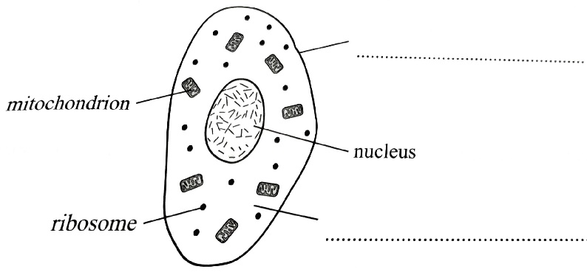
______________________________________________________________________________________________________________________________________________________________________________________________________________________________________________________

- Complete the diagram of the animal cell. (4)
Describe the roles of the following parts of the cell:

Mitochondria: ______________________________________________________________________ __________________________________________________________________________________
Nucleus: __________________________________________________________________________ __________________________________________________________________________________

Quiz 2: Organisation
- What is a tissue?  A – A collection of different types of cell that work together.  B – A collection of similar cells that work together. | - What colour is iodine solution in the presence of starch?  A – Blue-black  B – Brown-orange  C – Brick-red
- Where is bile produced and stored?  A – Produced in the liver and stored in the gall bladder.  B – Produced in the gall bladder and stored in the stomach.  C – Produced in the stomach and stored in the pancreas. | - True or False? “People who have problems with their immune system have an increase chance of summering from communicable diseases”.  A – True  B – False
- Which type of tumour is cancerous?  A – Benign  B - Malignant | - Which of these is NOT a chamber of the heart?  A – Left ventricle  B – Right atrium.  C- Vena Cava
- Which of these aren’t features of arteries?  A – Elastic fibres  B – Thick walls.  C – Valves. | - What is the function of palisade mesophyll tissue?  A – It covers the surface of the plant.  B – It’s where photosynthesis happens.  C – It carries substances around a plant.

- What is the role of protease enzymes? (1)
____________________________________________________________________________________________________________________________________________________________________

- Describe the function of phloem tissue. (1)
____________________________________________________________________________________________________________________________________________________________________

- Give two components of the blood that are carried in the blood plasma. (2)
- _______________________________________________________________________________
- _______________________________________________________________________________

- Describe what happens to an enzyme If the temperature is too high (3)
______________________________________________________________________________________________________________________________________________________________________________________________________________________________________________________

Quiz 3: Organisation
- True or False? “Organ systems work together to form organs.”  A – True  B – False | - What artificial device can be used to keep arteries open and blood flowing?  A – A ventilator  B – A valve  C – A stent
- When breathing in, which structure(s) does air enter first?  A – Alveoli  B – Trachea  C – Bronchi | - What is the function of white blood cells?  A – They deliver nutrients around the body.  B – They transport deoxygenated blood around the body.  C – They defend the body against microorganisms.
- Why is the shape of an enzyme important for its function?  A – So it can squeeze through small gaps.  B – So that it can enter the cells of the body.  C – So that it fits the substance involved in the reaction it is catalysing. | - What is the name of the cells that control the opening and closing of the stomata?  A – Palisade cells  B – Guard cells  C- Meristem cells
- True or False? “Blood flows to the organs through the veins.”  A – True  B – False | - Which of the following would you use to test for the presence of protein?  A – Biuret solution  B – Benedict’s solution  C – Iodine solution.

- Give one advantage of using an artificial heart rather than transplanting a natural one. (1)
____________________________________________________________________________________________________________________________________________________________________

- Give one risk factor that can increase a person’s chance of developing liver disease. (1)

__________________________________________________________________________________

- Describe what a benign tumour is. (1)
____________________________________________________________________________________________________________________________________________________________________
- Explain how increasing air movement around a plant’s eaves would affect the rate of transpiration. (4)
____________________________________________________________________________________________________________________________________________________________________________________________________________________________________________________________________________________________________________________________________________________________________________________________________________________________________________________________________________________________________________

Quiz 4: Infection and Response
- What is the first stage of testing a new medicinal drug?  A – The drug is tested on human cells and tissues in the lab.  B – The drug is tested on human volunteers in a clinical trial. | - How does the stomach help to defend the body against pathogens?  A – It secretes hydrochloric acid to kill pathogens  B – It contains hairs to trap pathogens  C – It secretes antibodies to kill pathogens
- What’s a microorganism that causes disease called?  A – An antibody  B – An antitoxin  C – A pathogen | - Which type of pathogen causes rose black spot on leaves?  A – Fungus  B – Bacterium  C - Virus
- Which drug was developed by Alexander Fleming?  A – Penicillin  B – Digitalis  C - Aspirin | - Gonorrhoea is a disease caused by…  A – …protists.  B - …viruses.  C- …bacteria.
- True or False? “Antibiotics can kill viruses.”  A – True  B – False | - Which type of drugs are used to control HIV?  A – Antibiotics  B – Antiretrovirals  C – Painkillers.

- Explain why the tobacco mosaic virus (TMV) affects the growth of plants. (2)
____________________________________________________________________________________________________________________________________________________________________
__________________________________________________________________________________

- Explain how mosquito nets help to prevent the spread of malaria. (2)
_____________________________________________________________________________________________________________________________________________________________________________________________________________________________________________________

- Explain how vaccination can protect against a disease. (3)
____________________________________________________________________________________________________________________________________________________________________________________________________________________________________________________________________________________________________________________________________________________________________________________________________________________________________________________________________________________________________________

Quiz 5: Infection and Response
- What is penicillin?  A – An antibiotic  B – An anti-viral drug  C – A painkiller | - True or False? “For a large outbreak of an infectious disease to be prevented, everyone must be vaccinated against it.”  A – True  B – False
- Which disease in humans can be partly controlled by vaccinating poultry against the pathogen?  A – Salmonella food poisoning  B – Gonorrhoea  C - Measles | - Which type of the following diseases is not spread by sexual contact?  A – HIV  B – Gonorrhoea  C - Measles
- What do white blood cells produce to help defend against pathogens?  A – Antigens  B – Antibiotics  C - Antibodies | - Which of the following diseases is caused by a protist?  A – Measles  B – Malaria  C - HIV
- Which of these statements about bacteria is false?  A – Bacteria damage cells by living and replicating inside them.  B – Some bacteria reproduce quickly in the body.  C – Bacteria can produce toxins. | - True or False? “Preclinical trials help to find the optimum dose for a drug”.  A – True  B – False

- How do viruses make you feel ill? (2)
____________________________________________________________________________________________________________________________________________________________________
__________________________________________________________________________________

- How does the nose help to defend the body against disease? (2)
______________________________________________________________________________________________________________________________________________________________________________________________________________________________________________________
- What is a double-blind trial and why is it used for clinical trials? (3)
____________________________________________________________________________________________________________________________________________________________________________________________________________________________________________________________________________________________________________________________________________________________________________________________________________________________________________________________________________________________________________

Quiz 13: Homeostasis and Response
- When a woman has a low level of FSH, her…  A – …uterus lining is not maintained.  B - …eggs do not mature.  C - …mature eggs are not stimulated to release. | - How many days does the menstrual cycle usually last for?  A – 52 days  B – 7 days  C – 28 days
- Reaction time is the time it takes for someone to…  A – …detect a stimulus  B – …respond to a stimulus  C - …remember something. | - Which of the following is an example of a coordination centre?  A – Skin  B – Pancreas  C - Muscle
- Which of the following is a barrier method of contraception?  A – Diaphragm  B – Contraceptive patch  C – Intrauterine device | - The gland which releases thyroxine is…  A - …the pituitary gland  B - …the adrenal gland  C - …the thyroid gland
- Which is the central nervous system made up of?  A – The brain and receptors  B – The brain and spinal cord  C – The spinal cord and receptors | - Which is the correct pathway for stimuli along the reflex arc?  A – Relay neurone sensory neurone motor neurone.  B – Sensory neurone motor neurone relay neurone.  C- Sensory neurone relay neurone Motor neurone

- Give two roles that thyroxine has in the body. (2)
- _______________________________________________________________________________
- _______________________________________________________________________________

- Explain what Type 1 diabetes is, and why is it dangerous. (2) __________________________________________________________________________________
____________________________________________________________________________________________________________________________________________________________________

- List three internal conditions that your body needs to keep constant to survive. (3)
- _______________________________________________________________________________
- _______________________________________________________________________________
- _______________________________________________________________________________

Quiz 14: Homeostasis and Response
- What is the hormone that controls the ‘fight or flight’ response?  A – Thyroxine  B – Adrenaline  C - Glucagon | - True or False? “Caffeine can affect a person’s reaction time”.  A – True  B - False
- The contraceptive implant continuously releases progesterone, which…  A – …stimulates the production of FSH.  B – …stops the ovaries releasing eggs.  C - …acts as a spermicidal agent. | - In the menstrual cycle, what effect does the release of oestrogen have on LH and FSH?  A – It stimulates the release of LH and FSH.  B – It inhibits the release of LH and stimulates the release of FSH.  C – It stimulates the release of LH and inhibits the release of FSH.
- Where in the body would you find the adrenal gland?  A – Neck  B – Brain  C – Just above the kidneys. | - True or False? “The blood sugar level of someone with Type 1 diabetes is always dangerously low”.  A – True  B - False
- What is secreted by the pancreas when blood glucose levels fall?  A – Glucose  B – Insulin  C - Glucagon | - True or False? “Hormones have longer-lasting effects than nervous impulses”.  A – True  B - False

- What is the role of LH in the menstrual cycle? (1)
__________________________________________________________________________________

- What type of neurone transmits impulses to an effector in the nervous system? (3)
__________________________________________________________________________________
Give an example of an effector and describe how it responds to a stimulus.
__________________________________________________________________________________
____________________________________________________________________________________________________________________________________________________________________

- What is meant by the term homeostasis? (3)
__________________________________________________________________________________
______________________________________________________________________________________________________________________________________________________________________________________________________________________________________________________

Quiz 15: Inheritance, Variation and Evolution
- True or False? “Selective breeding can happen without human intervention”.  A – True  B - False | - What effect do mutations have on variation?  A – They decrease it.  B – They increase it.  C – There is no effect.
- When an individual has one dominant and one recessive allele…  A – …the recessive allele is expressed.  B – …both alleles are expressed.  C - …the dominant allele is expressed. | - True or False? “Fossils can be formed from an organisms footprints and burrows that have been preserved over time”.  A – True  B - False
- How many chromosomes does a human gamete have?  A – 46  B – 12  C – 23 | - What sex chromosomes does someone who is biologically male have?  A – XY  B – XXX  C - XX
- What is the main idea behind Darwin’s theory of evolution by natural selection?  A – There is variation in a population. Those more suited to the environment will be more likely to survive and pass on their characteristics.  B – individuals develop characteristics during their lifetimes, which make them more suited to their environment. They pass these onto their offspring. | - How are genes ‘cut out’ from chromosomes in genetic engineering?  A – Using enzymes  B – Using bacteria  C – Using a knife

- What is a fossil? (1)
____________________________________________________________________________________________________________________________________________________________________

- Give two pieces of evidence that support Darwin’s theory of evolution. (2)
- _______________________________________________________________________________
- _______________________________________________________________________________

- Suggest two reasons why someone may be against embryonic screening. (2)
- _______________________________________________________________________________
- _______________________________________________________________________________

- Briefly describe the role of a vector in genetic engineering and give one example of a vector used. (2) ______________________________________________________________________________________________________________________________________________________________________________________________________________________________________________________

Quiz 16: Inheritance, Variation and Evolution
- True or False? “The alleles for cystic fibrosis and polydactyly are both dominant”.  A – True  B - False | - If a farmer wants to increase the meat yield of his cows, he would breed together…  A – …the biggest cows.  B - …those that produced the most milk.  C - …those with a gentle temperament.
- What is an organism’s genotype?  A – The characteristics that the organism has.  B – The alleles that the organism has. | - How often do mutations result in a new phenotype?  A – Always  B – Often  C – Very rarely.
- What do evolutionary trees show?  A – Evolutionary relationships  B – Parental relationships  C – Genetic disorders | - What is a problem that could result from patients not finishing a course of antibiotics?  A – Antibiotic resistance increases in bacteria.  B – Antibiotic resistance increases in viruses.  C – Immunity to disease increases in humans.
- How many cell divisions occur during meiosis?  A – 1  B – 2  C - 4 | - What is the correct order of classification groups?  A – Kingdom, genus, class, order, family, phylum, species.  B – Family, phylum, species, order, kingdom, genus, class.  C – Kingdom, phylum, class, order, family, genus, species.

- A tall pea plant with two dominant ‘T’ alleles and a dwarf pea plant with two recessive ‘t’ alleles are crossed to produce a pea plant with the genotype Tt. What will the new plant’s phenotype be? Explain your answer. (2)
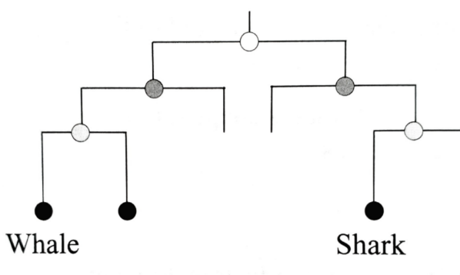
________________________________________________________________________________________________________________________________________________________________________________________________________________________________________________________________________________________________________________________________________

- The diagram shows a simple evolutionary tree. Use it to describe how the whale and shark are related in terms of distant and recent ancestors. (2)
_____________________________________________
_____________________________________________
_____________________________________________

- Explain how sexual reproduction produces variation. (3) ________________________________________________________________________________________________________________________________________________________________________________________________________________________________________________________________________________________________________________________________________

