Sixth Form

A level Biology (AQA)

Bridging Work Booklet


Name:…………………………………………………………………………………………………….

Welcome to HGS Biology!
This bridging work is designed to help you bridge the gap between your GCSE Science studies and the AS/A level Biology course.
Why do bridging work?
Preparation is crucial for studying A level Biology. After completing these exercises, you will need to highlight any areas that you really had trouble understanding. We are expecting you to put 100% effort into these tasks to show your commitment to a 2-year course. All of these are essential in the understanding of the foundations of biology.
We want you to be successful at A-level Biology and what this takes at GCSE is different to what is required at A-level. Although you have fewer subjects, there are different skills post-16 and the volume of work is greater due to the increased demand of depth and detail.
Bridging work should help you to gauge your current understanding of the subject and introduce you to the depth of understanding that is required for study at post-16.
Is the bridging work assessed?
Yes. In September, your subject teacher will ask you for your bridging work and it will be assessed. Teachers can diagnose your strengths and weaknesses and begin to support you in a more targeted way.
Biology A-level
Studying Biology (or, in fact any subject) at A-level will require you to be highly organised and effective with your own independent work. Not only will you have to balance workload of this subject and the other subjects you have chosen, you will also be required to commit to the subject and do the best you can.
Anyone not completing the work or producing that or a poor quality will be spoken to and asked to re-consider whether this is the right course for you. Please use resources such as the internet, library and your Biology GCSE notes to help you complete this booklet.
As part of your AS/A level studies you will have 10 lessons a fortnight in your timetable. In these lessons you will cover all the theory and practical work required for the course. You are also expected to spend at least five hours a week on your Biology work outside of lessons. This will include homework tasks, pre-reading, independent study tasks, making additional notes, reviewing lesson materials and reading around the subject. To allow you to make a start on this, a suggested reading list has been included at the end of this pack.

Examination Details
Paper 1 | Paper 2 | Paper 3
What’s assessed  - Topics 1-4  - Relevant practical skills | What’s assessed  Topics 5-8  Relevant practical skills | What’s assessed  Topics 1-8  Relevant practical skills
Assessment  - 2hrs  - 91 marks  35% of A level | Assessment  - 2hrs  - 91 marks  35% of A level | Assessment  - 2hrs  - 78 marks  30% of A level
Questions  - 76 marks: a mixture of short and long answer questions  - 15 marks: extended response questions | Questions  - 76 marks: a mixture of short and long answer questions  - 15 marks: extended response questions | Questions  - 38 marks: structured questions, including practical techniques  - 15 marks: critical analysis of given experimental data  - 25 marks: one essay from a choice of two titles

You should bring this bridging work with you to your first year 12 Biology lesson in September.
Securing: Complete section A
Processing: Complete section B
Exploring: Complete section C

If you need to do more preparation……
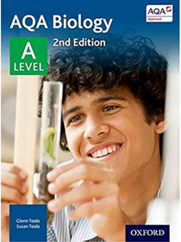
To support your learning you will what to perhaps purchase some of the following textbooks they need not be brand new;
AQA Biology: A Level Student Book: September 2015
- ISBN-10 ‏ : ‎ 0198351771
- ISBN-13 ‏ : ‎ 978-0198351771
- Publisher Oxford University Press

Try “Head start” to A level Biology
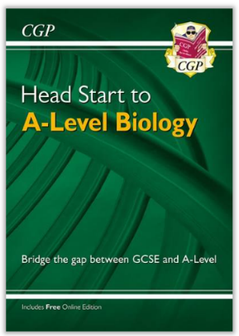
ISBN 9781782942795
Buy online at: https://www.cgpbooks.co.uk/
Online £4.95
It helps recap all the tricky topics from GCSE that AS builds on.
It is ideal preparation for September no matter what GCSE option you
have followed. It will also be useful for reference throughout the course.

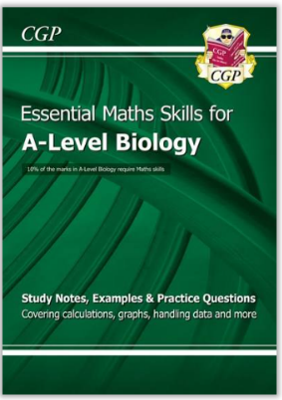
Try “A level Biology: Essential maths skills”
ISBN 9781847623232
Buy online at https://www.cgpbooks.co.uk/
Online £8.15
It helps to take your through step by step calculations from
calculating means, standard deviations to statistical testing.
It is ideal support throughout the course.

Further to these resources, your teachers are, of course, an excellent source of support both in and out of lessons. Other support includes drop-in subject support classes outside of school hours, MedSoc (those wishing to study medicine after A levels) and further Biology enrichment options to help support your studies.
Additional texts will be available in the school library and a full copy of the specification (you should download this for use in lessons), past papers etc. can be accessed through the AQA website:
https://www.aqa.org.uk/subjects/biology/a-level/biology-7402/specification/specification-at-a-glanceBiology

Useful Websites
AQA A-level Biology Revision - PMT
https://www.physicsandmathstutor.com/biology-revision/a-level-aqa/
Cognito Science (revision tools)
https://cognitoedu.org/home
Seneca (revision tools-will be given a login in September)
https://senecalearning.com/en-GB/
Youtube
Miss Estruch
https://www.youtube.com/c/MissEstruch
Primrose Kitten
https://www.youtube.com/channel/UCBgvmal8AR4QIK2e0EfJwaA
Amoeba Sisters
https://www.youtube.com/@amoebasisters

Section A activities

Useful information
There are a number of activities throughout this resource. The answers to which your teacher will provide in September.

SI Units
Every measurement must have a size and a unit. Sometimes, there are different units available for the same type of measurement. For example, ounces, pounds, kilograms and tonnes are all used as units for mass.
To reduce confusion, and to help with conversion between units, there is a standard system of units called SI units which are used for most scientific purposes.
These units have all been defined by experiment so that the size of say, a metre in the UK is the same as a metre in China.
The seven SI base units are;
Physical quantity | Usual quantity symbol | Unit | Abbreviation
Mass | m | kilogram | kg
Length | l or x | metre | m
Time | t | second | s
Electric current | I | ampere | A
temperature | T | kelvin | K
Amount of substance | N | mole | mol
Luminous intensity | (not used at A level) | candela | cd

All other units can be derived from the SI base units. For example, area is measured in square metres (m²) and speed is measured in metres per second (ms⁻¹).
It isn’t always appropriate to use a full unit. For example, measuring the width of a hair or the distance between Manchester and London in metres would could the numbers to be difficult to work with.
Prefixes are used to multiply each of the units. The most common ones are centi (meaning 1/100), kilo (1000) and milli (1/1000).
There are a wide range of prefixes. The majority of quantities in scientific contexts can be quoted using prefixes that are multiples of 1000. For example, a distance of 33000m would be quoted as 33km.

The most common prefixes are:
Prefix | Symbol | Multiplication factor
Tera | T | 10¹² | 1 000 000 000 000
Giga | G | 10⁹ | 1 000 000 000
Mega | M | 10⁶ | 1 000 000
kilo | k | 10³ | 1000
deci | d | 10⁻¹ | 0.1 | 1/10
centi | c | 10⁻² | 0.01 | 1/100
milli | m | 10⁻³ | 0.001 | 1/1000
micro | µ | 10⁻⁶ | 0.000 001 | 1/1 000 000
nano | n | 10⁻⁹ | 0.000 000 001 | 1/1 000 000 000
pico | p | 10⁻¹² | 0.000 000 000 001 | 1/1 000 000 000 000
femto | f | 10⁻¹⁵ | 0.000 000 000 000 001 | 1/1 000 000 000 000 000

Activity 1
Which SI unit and prefix would you use for the following quantities?
1.The time between heart beats

2. The length of a leaf

3. The distance that a migratory bird travelled each year

4.The width of a cheek cell

5.The mass of a rabbit

6.The mass of iron in the body

7.The volume of the trunk of a large tree

Important vocabulary for practical work
You will have come across most of the words used in practical work in your GCSE studies. It is important that you use the right definition for each word. Please complete the subsequent activities for September.
Activity 2
Join the boxes to link the word to the definition- or colour code
Accurate |  | A statement suggesting what may happen in the future.
Data |  | An experiment that gives the same results when a different person carries it out, or a different set of equipment or technique is used.
Precise |  | A measurement that is close to the true value.
Prediction |  | An experiment that gives the same results when the same experimenter uses the same method and equipment.
Range |  | Physical, chemical or biological qualities or characteristics.
Repeatable |  | A variable that is kept constant during an experiment.
Reproducible |  | A variable that is measured as the outcome of an experiment.
Resolution |  | This is the smallest change in the quantity being measured (input) of a measuring instrument that gives a perceptible change in the reading.
Uncertainty |  | The interval within the true value can be expected to lie.
Variable |  | The spread of data, showing the maximum and minimum values of the data.
Control Variable |  | Measurements where repeated measurements show very little spread.
Dependent Variable |  | Information, in any form, that has been collected.

Cells
All life on Earth exists as cells. These have basic features in common.
Activity 3
Complete the table
Structure | Function
Cell-surface membrane
Chloroplast
Cell Vacuole
Mitochondria
Nucleus
Cell Wall
Chromosomes
Ribosomes

Photosynthesis and Respiration
Two of the most important reactions that take place in living things are photosynthesis and respiration. They both involve the transfer of energy.
Activity 4
Complete the table
 | Photosynthesis | Respiration
Which organisms carry out this process?
Where in the organisms does the process take place?
Energy store at the beginning of the process | Sun
Energy store at the end of the process |  | In Cells
Reactants needed for the process
Products of the process
Overall word equation
Balanced symbol equation for the process
Which of the answers for aerobic respiration would be different for anaerobic respiration?
Add these answers to the table in a different colour.

Principles of moving across boundaries
In biology, many processes involve moving substances across boundaries.
Activity 5
Match the examples to the principle(s) involved. For each, give a brief description of why it is relevant.
Osmosis |  | Examples  Potato pieces get heavier when put in pure water  The effect of salt on slugs
Diffusion |  | Drinking a sports drink  Cacti do not have thin, large leaves  Gas exchange in the lungs
Active transport |  | Absorbing nutrients from food into the body  Moving ions into cells
Changing surface area or length |  | Penguins huddling together to keep warm  Potato pieces get lighter when put in pure water

Genetic Inheritance
Activity 6
Huntington’s disease is an example of a disease where the mutation causing the disease is dominant.

h: normal (recessive)
H: mutation (dominant)

 |  | Paternal Alleles
 |  | H | h
Maternal Alleles | h
Maternal Alleles | h

Cystic fibrosis is an example of a disease where mutation causing the disease is recessive.
F: Normal (recessive)
f: mutation (dominant)
 |  | Paternal Alleles
 |  | F | f
Maternal Alleles | F
Maternal Alleles | f

For each Punnett square;
  - Complete the diagrams to show the alleles for each child
  - State the genotypes
  - State the phenotypes
  - State which parent and child is;
- Healthy
- Has the disease
- Carrier

Analysing Data
Biological investigations often result in large amounts of data being collected. It is important to be able to analyse this data carefully in order to pick out trends.
Activity 7
A student investigated an area of moorland where succession was occurring. She used quadrats to measure the area covered by different plant species, bare ground and surface water every 10 metres along a transect. She also recorded the depth of the soil at each quadrat. Her results are shown in the table.
 | Area covered in each quadrat A to E in cm²
 | A | B | C | D | E
Bog Moss | 55 | 40 | 10 | - | -
Bell Heather | - | - | - | 15 | 10
Sundew | 10 | 5 | - | - | -
Ling | - | - | - | 15 | 20
Bilberry | - | - | - | 15 | 25
Heath grass | - | - | 30 | 10 | 5
Soft rush | - | 30 | 20 | 5 | 5
Sheep’s fescue | - | - | 25 | 35 | 30
Bare ground | 20 | 15 | 10 | 5 | 5
Surface water | 15 | 10 | 5 | - | -
Soil depth/cm | 3.2 | 4.7 | 8.2 | 11.5 | 14.8
    - Indicates zero cover
Calculate:
- The mode area of soft rush in the sample
- The mean soil depth
- The median amount of bare ground in the sample

Section B Activities

Part 1
Watch the video about DNA Structure provided below make notes on the following:
• The structure of DNA nucleotides, include all components.
- Include an annotated diagram of one DNA nucleotide.
• Name the four scientists credited with discovering the double-helix structure of DNA.
• State the number of hydrogen bonds between the complementary base pairs.
• How can the structure of the pyrimidine and purine bases help you identify which bases are paired together in the DNA molecule?
• Draw an annotated diagram of DNA.
Part 2
- Why do we need RNA?
- Compare the structure of DNA to RNA?
- How is the structure of DNA related to its function?
- Outline some of the problems that occur with DNA replication and what consequences of this might be

Use these resources to help you
DNA Structure (youtube.com) https://www.youtube.com/watch?v=C1CRrtkWwu0
DNA vs RNA
https://www.youtube.com/watch?v=JQByjprj_mA
You can also use the following websites to help with the task:
DNA Structure and The Double Helix (A-level Biology) - Study Mind
https://studymind.co.uk/notes/dna-structure-and-the-double-helix/

You can also use any other research sources and materials you wish.

Section C Activities
Science communication is essential in the modern world and all the big scientific companies, researchers and institutions share their developments through social media platforms and through accessible presentations.
Below are suggested videos/ films/ ted talks/ websites that may be useful to prepare you for Biology A Level. Some are linked to topics at GCSE and those you will learn about at A Level, some are to give you a wider understanding.
You are not expected to watch them all- you can choose those that are most interesting to you and produce Cornell notes on them!
• https://www.ted.com/topics/biology
These ones are particularly interesting...
- https://www.ted.com/talks/paula_hammond_a_new_superweapon_in_the_fight_against_cancer?language=en
- https://www.ted.com/talks/marla_spivak_why_bees_are_disappearing?language=en
- http://ed.ted.com/lessons/the-twisting-tale-of-dna-judith-hauck
- http://ed.ted.com/lessons/where-do-genes-come-from-carl-zimmer
- http://ed.ted.com/lessons/how-to-sequence-the-human-genome-mark-j-kiel
- http://ed.ted.com/lessons/the-race-to-sequence-the-human-genome-tien-nguyen
- http://ed.ted.com/lessons/why-is-biodiversity-so-important-kim-preshoff
- http://ed.ted.com/lessons/can-wildlife-adapt-to-climate-change-erin-eastwood
- http://ed.ted.com/lessons/insights-into-cell-membranes-via-dish-detergent-ethan-perlstein
- http://ed.ted.com/lessons/what-do-the-lungs-do-emma-bryce
- https://www.ted.com/talks/robert_sapolsky_the_biology_of_our_best_and_worst_selves
Websites
1. http://www.ibiblio.org/virtualcell/index.htm - An interactive cell biology site.
2. http://www.accessexcellence.org/RC/VL/GG - A web site showing illustrations of many processes of biotechnology.
3. http://www.dnai.org/a/index.html - Explore the genetic code.
4. http://nobelprize.org - Details of the history of the best scientific discoveries.
5. http://nature.com - The site of the scientific journal.
6. http://royalsociety.org - Podcasts, news and interviews with scientists about recent scientific developments.
7. http://www.nhm.ac.uk - The London Natural History Museum’s website with lots of interesting educational material.
8. http://www.bmj.com - The website of the British Medical Journal.

Section D Activities

If you have entered the course from the combined pathway (trilogy or synergy) you may need to review the following topics;

Topics | Trilogy | Separate
Plant diseases and defences | X | 
Brain and eye | X
Thermoregulation | X
Advanced Genetics and gene expression | X
Biotechnology | X
Reproduction hormones and IVF | Basic | In-depth
Genetic Engineering and Cloning | Limited | Detailed

Please use the following websites to support your understanding;
https://www.bbc.co.uk/bitesize/examspecs/zpgcbk7
https://www.physicsandmathstutor.com/biology-revision/gcse-aqa/

Complete the 10min test booklet and review your results and provide evidence of how you have addressed your weaknesses; mindmaps/practice questions/flashcards.

Massive Open Online Courses (MOOCs)

You might enrol on these online courses and complete the following to push you a little further (this is optional). These courses are a fantastic addition to your UCAS:
HarvardX: Cell Biology:

UniversityofCambridge: Forensic Science: DNA Analysis | edX

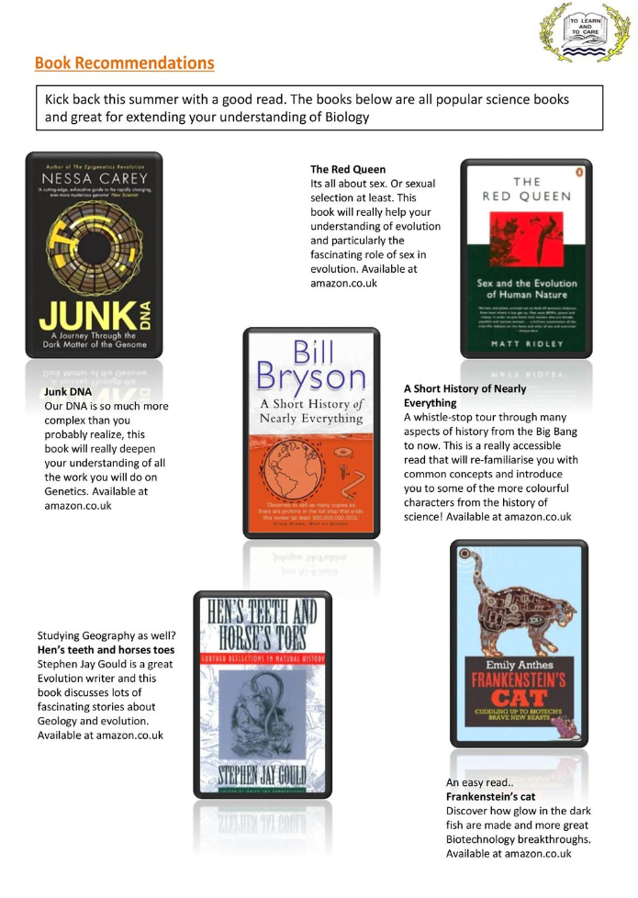

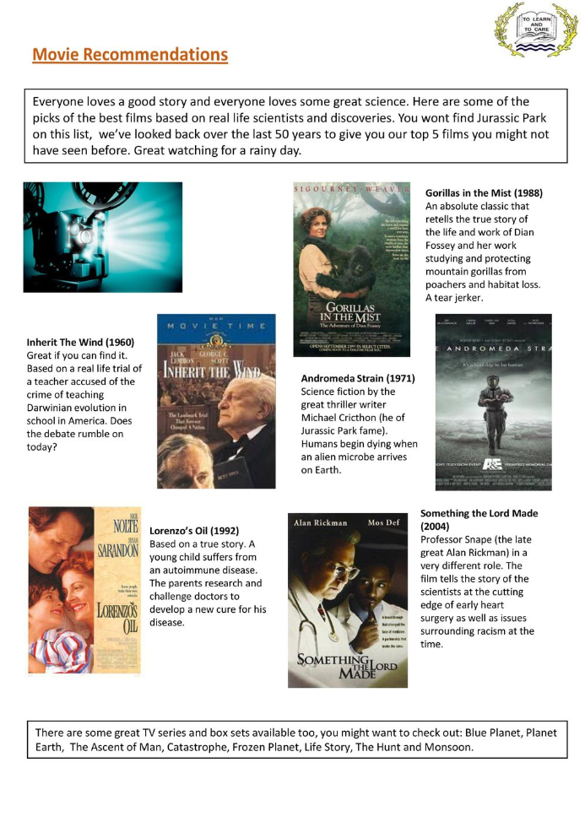

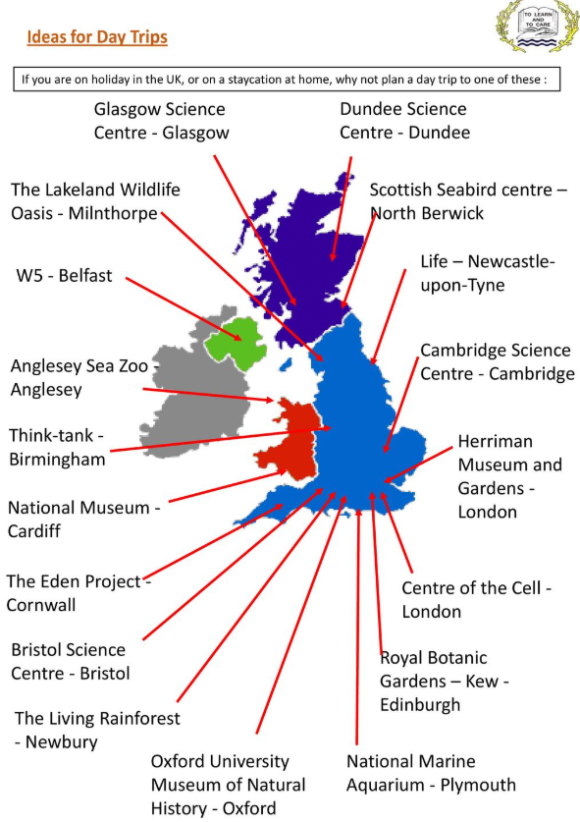

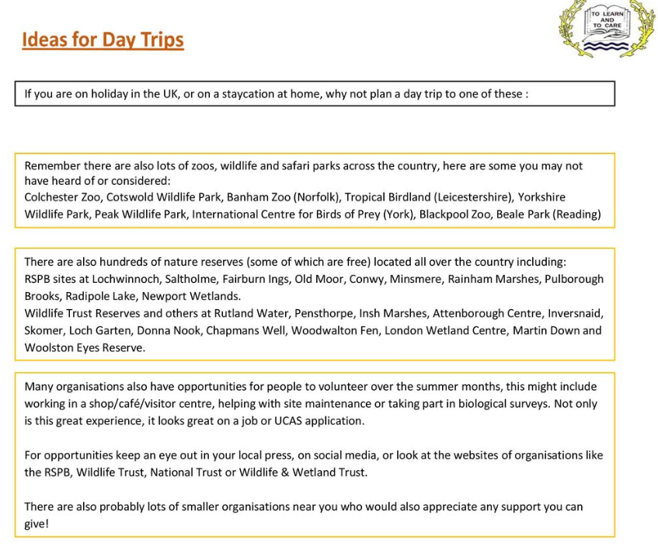

Science on Social Media

Facebook
- Nature- the profile page for nature.com for news, features, research and events from Nature Publishing Group

- Marine Conservation Institute- publishes the latest science to identify important marine ecosystems around the world

- Science news magazine- Science covers important and emerging research in all fields of science

- BBC Science News- The latest BBC science and Environment news: breaking news, analysis and debate on science and nature around the world

X
- Carl Zimmer- Scientific writer Carl blogs about life sciences @carlzimmer
- Phil Plait- tweets about astronomy and bad science @badastronomer
- Maryn McKenna- science journalist who writes about antibiotic resistance @marynmck
- Sci Curious- feed from writer and Bethany Brookshire tweeting about good, bad and weird neuroscience @scicurious
- New Scientist- scientific journal of recent scientific developments @newscientist
- Science and Nature- Unravelling the mysteries of the natural world, one video at a time @ScienceFun16180

TikTok
- @miss.estruch.biology- A-level and GCSE Biology. Live and free lessons every Thurs 8pm
- @up.learn- Online platform to help with A level revision
- @primrose.kitten- Making revision easy on Youtube or Primrose kitten academy
- @mattgreen.jgm- the rapping science teacher
- @instituteofhumananatomy- shares facts about human biology, offering a close-up look at the human body
- @biologywitholivia offers GCSE and A level revision videos
- @billnye- Bill Nye the Science Guy offers science related content, including informative videos and engaging discussions

