15 January 2026

Dear Parent/Carer and Student
Year 11 Leavers’ Ball & Hoodies
Please find below some information about the plans for various activities to celebrate the end of Year 11.
Leavers’ Ball 2026 – Friday 19 June 2026
We are delighted to announce that the Year 11 Leavers’ Ball will take place on Friday 19 June in school.
Feedback from previous years has shown that holding the event externally did not provide the best value for money or the most enjoyable experience for students. Current Year 11 students have expressed a desire to have more input into the format of the evening.
By hosting the event in school, students will take the lead in planning, ensuring the celebration reflects their ideas and preferences. This approach will also allow us to deliver better value for money and a higher standard of catering, making the evening truly special.
The Ball will commence at 7.00pm and finish at 11.00pm.

If you would like your son or daughter to attend, please ensure the full payment of £25 is received via the Trips section of Arbor Pay by Friday 8 May 2026.

We hope that students will have a memorable and enjoyable time, but we do insist on appropriate behaviour. Consumption of alcohol will not be accepted, either at the venue or prior to the event. Soft drinks will be available to purchase.
Please ensure that provision is made for your son/daughter to be collected at the end of the evening.
Year 11 Leavers’ Hoodies
The Year 11 leavers' hoodies are once again being organised through Emblazon in Harrogate.
The cost of these hoodies will be £28. This includes the embroidery of the school crest on the front and the printing of ‘Leavers’ on the left sleeve and the student’s name or (appropriate) nickname on the back.
To order the hoodie please make the payment online via the Trips section of Arbor Pay and complete the order form (link below) by Friday 20 February 2026. Due to the lead time required to produce the hoodies, payments and/or orders after this date will not be considered.
Leavers Hoodie Order Form 2026
Below is the sizing guide for the hoodies, please keep this in mind when completing the online form as there will be no chance to change hoodie size once they have been ordered. If in doubt, order the larger size just in case.
Size | Chest (inches) | Hoodie Design Example  Colour – Black Melange
Adult XS | 32-34 |   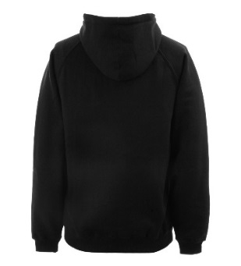  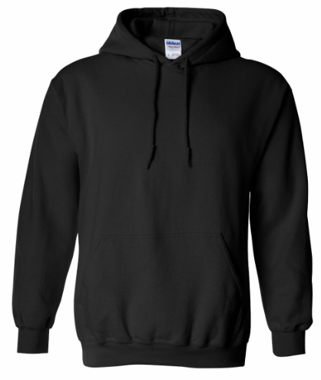  NICKNAME  23  ‘LEAVERS’ ON LEFT SLEEVE
Adult S | 34-36
Adult M | 38-40
Adult L | 42-44
Adult XL | 46-48
Adult XXL | 50-52
Adult XXXL | 52-54

Summary
We appreciate that this is an expensive time and have therefore spread the costs where possible.
Activity | Deadline | Amount due
Leavers’ Hoodies  Payment via Arbor  Completed Leavers Hoodie Order Form 2026 | Friday 20 February 2026 | £28
Leavers’ Ball  Payment via Arbor | Friday 8 May 2026 | £25

If you have any questions regarding the Year 11 Ball or Hoodies, please do not hesitate to contact the school (mail@hgs.rklt.co.uk).
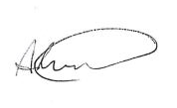
Yours sincerely
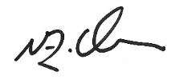

Mr Thurley Mr Mason
Year 11 Manager Director of Upper School

